30 October, 2026

PRESS RELEASE

REVENUE FROM TOURISM: AUGUST 2026

Revenue from Tourism -3,4%

Based on the results of the Passengers Survey carried out by the Statistical Service, revenue from tourism reached €562,0 mn in August 2026, recording a decrease of 3,4% compared to the corresponding month of the previous year (€581,8 mn).

For the period of January – August 2026, revenue from tourism is estimated at €2.319,8 mn compared to €2.472,9 mn in the corresponding period of 2025, recording a decrease of 6,2%.

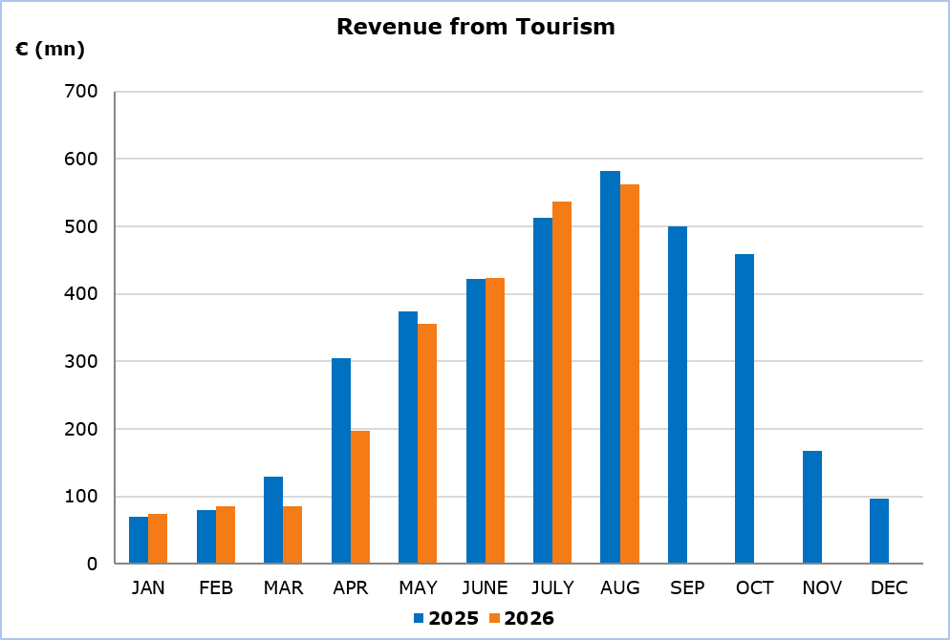

Expenditure Analysis

The average expenditure per person was €965,81 in August 2026, remaining at the same level as in August 2025 (€966,41).

Tourists from the United Kingdom (the largest tourist market with 30,5% of the total tourists in August 2026) spent on average €104,13 per day, while tourists from Israel (the second largest market during the specific month with 23,3% of the total tourists) spent on average €178,44. Tourists from Poland (the third largest market with 6,3%) spent on average €92,40 per day.

Detailed statistics on the average expenditure of tourists per person and per day by country of usual residence are presented in the following table.

Table
Country of Usual Residence | August 2025 |  |  |  | August 2026
Country of Usual Residence | Tourist Arrivals | Average Length of Stay | Expenditure (€) |  | Tourist Arrivals | Average Length of Stay | Expenditure (€)
Country of Usual Residence | Tourist Arrivals | Average Length of Stay | Per Person | Per Day | Tourist Arrivals | Average Length of Stay | Per Person | Per Day
TOTAL | 602.026 | 9,2 | 966,41 | 105,04 | 581.880 | 8,9 | 965,81 | 108,52
Austria | 11.935 | 7,4 | 899,80 | 121,59 | 10.389 | 9,1 | 1.116,79 | 122,72
Belgium | 3.342 | 10,2 | 918,56 | 90,05 | 4.475 | 13,3 | 1.064,54 | 80,04
France | 15.663 | 9,4 | 979,40 | 104,19 | 8.453 | 11,2 | 1.034,62 | 92,38
Germany | 27.665 | 10,5 | 987,97 | 94,09 | 25.823 | 10,2 | 1.084,18 | 106,29
Denmark | 9.984 | 8,8 | 836,78 | 95,09 | 9.733 | 7,7 | 780,74 | 101,39
Switzerland | 7.277 | 8,9 | 1.254,87 | 141,00 | 6.739 | 9,2 | 1.423,77 | 154,76
Greece | 15.294 | 10,5 | 484,94 | 46,18 | 13.810 | 10,2 | 466,29 | 45,71
United States | 8.597 | 12,2 | 849,70 | 69,65 | 9.665 | 16,7 | 1.691,60 | 101,29
United Kingdom | 193.091 | 10,6 | 1.195,02 | 112,74 | 177.603 | 10,2 | 1.062,12 | 104,13
Israel | 105.597 | 5,2 | 792,69 | 152,44 | 135.628 | 5,0 | 892,20 | 178,44
Italy | 11.173 | 8,5 | 773,38 | 90,99 | 6.282 | 8,1 | 928,95 | 114,69
Lebanon | 5.745 | 7,6 | 719,93 | 94,73 | 5.085 | u | u | u
Norway | 7.896 | u | u | u | 8.006 | u | u | u
Netherlands | 7.672 | 9,7 | 1.103,80 | 113,79 | 6.331 | 10,9 | 1.062,19 | 97,45
Poland | 41.844 | 7,7 | 740,38 | 96,15 | 36.622 | 7,9 | 729,93 | 92,40
Sweden | 18.636 | 8,4 | 876,21 | 104,31 | 17.441 | 8,8 | 1.024,42 | 116,41
Finland | 4.018 | u | u | u | 3.431 | 9,2 | 1.105,20 | 120,13
u: Data with low reliability.

METHODOLOGICAL INFORMATION

Definitions

Tourists – Visitors who stay for at least one night in Cyprus.

Tourist arrivals – The term refers to the number of trips and not to the number of persons. This differs in the sense that one person can take more than one trip during the reference period.

Revenue from Tourism - It refers to the revenue from tourists during their visit in Cyprus.

Source of Data and Coverage

The data on the expenditure of tourists is obtained from the Passengers Survey which is carried out at the points of departure in Larnaka and Pafos airports. The data is collected through personal interviews with the use of an electronic questionnaire (CAPI method – Computer Assisted Personal Interviewing).

The data covers all persons in the Government controlled area of Cyprus. It does not include travelers who arrive and depart illegally via ports and airports in the occupied part of Cyprus.

For more information:
CYSTAT Portal, subtheme Tourism
CYSTAT-DB (Online Database)
Predefined Tables (Excel)
Methodological Information

Contact
Lucy Panayidou: Tel.:+35722602152, E-mail: lpanagidou@cystat.mof.gov.cy

